Supplementary figures

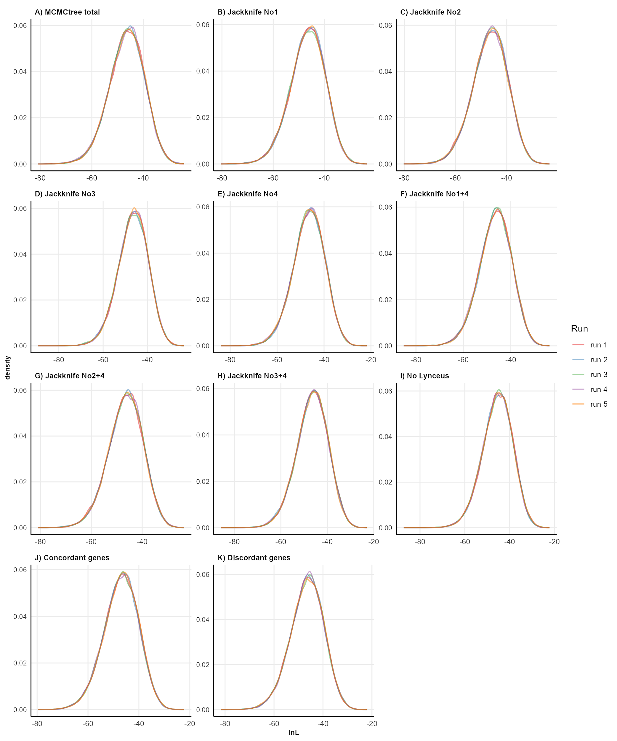
SUPPLEMENTARY FIGURE S1. Tracer plots of lnL values for each MCMCtree analysis. Numbers for jackknife resampling are the same as in Fig. 1 and Supp. Table S1.
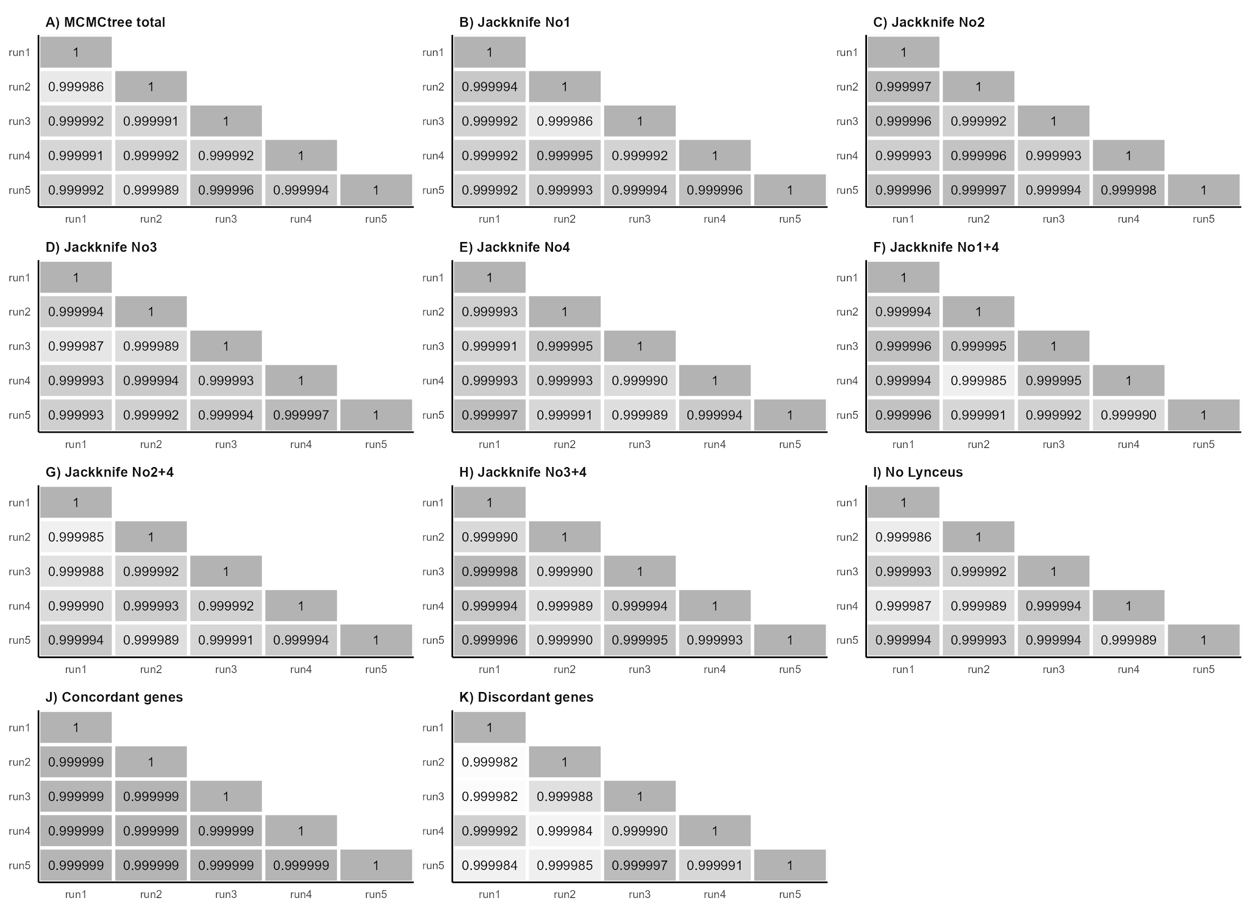
SUPPLEMENTARY FIGURE S2. Pairwise correlations of mean age estimates of the 5 runs for each MCMCtree analysis. Numbers of jackknife resampling are the same as in Fig. 1 and Supp. Table S1.

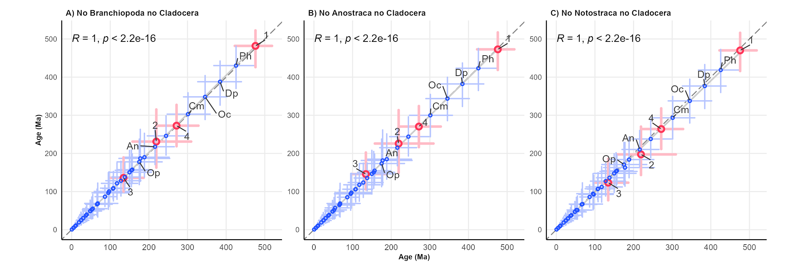SUPPLEMENTARY FIGURE S3. Correlations of age estimates between the timetree calibrated with all 5 age priors (Table 1) and timetrees calibrated using the joint jackknife resampling of age priors (two nodes each time). Error bars are shown for each estimate. Red points indicate calibration nodes and numbers are the same as in Fig. 1 and Table 1. Dashed lines represent the bisector of the quadrant, while solid lines represent the linear regression of plotted data. The root node and the node of Ischnura elegans + Sinella curviseta (outgroups) were removed. Pearson’s correlation coefficients (R) and the associated p-values are provided. Ph: Phyllopoda; Dp: Diplostraca; Oc: Onychocaudata; Cm: Cladoceromorpha; An: Anomopoda; Op: Onychopoda.

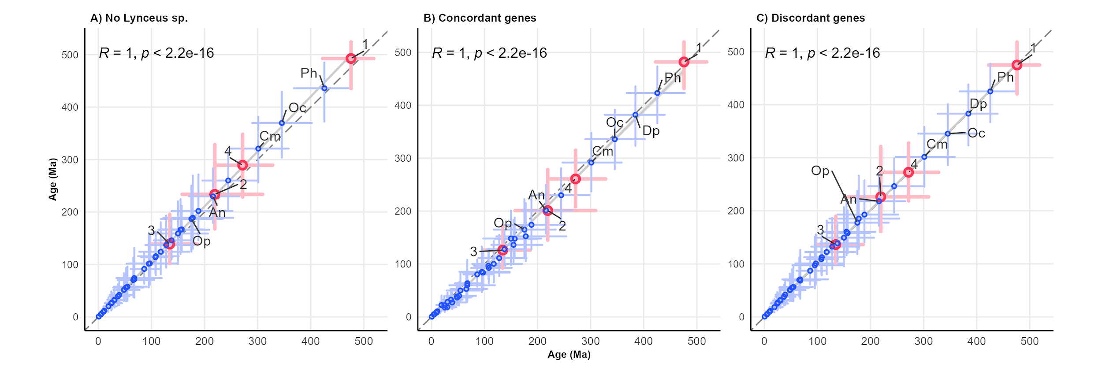
SUPPLEMENTARY FIGURE S4. Correlations of age estimates between the timetree calibrated with 5 calibrated with 5 age priors (Table 1) and timetrees calibrated after phylogenetic trees built with different alignments. Error bars are shown for each estimate. Red points indicate calibration nodes and numbers are the same as in Fig. 1 and Table 1. The root node and the node of Ischnura elegans + Sinella curviseta (outgroups) were removed. Pearson’s correlation coefficients (R) and the associated p-values are shown. Ph: Phyllopoda; Dp: Diplostraca; Oc: Onychocaudata; Cm: Cladoceromorpha; An: Anomopoda; Op: Onychopoda.

SUPPLEMENTARY TABLES
Species | ID | Subclass | Superorder | Group | Order | Family | GenBank Accession Number | BUSCO statistics | BUSCO genes for phylogenomics | Reference
Ischnura elegans | Iele | Outgroup | Outgroup | Outgroup | Outgroup | Outgroup | GCA_921293095.1 | C:98.0%[S:97.4%,D:0.6%], F:0.9%, M:1.1% | 134 | Price et al., 2022
Sinella curviseta | Scur | Outgroup | Outgroup | Outgroup | Outgroup | Outgroup | GCA_004115045.3 | C:96.3%[S:93.7%,D:2.6%], F:1.3%, M:2.4% | 129 | Zhang et al., 2019
Branchinecta lindahli | Blin | Sarsotraca | - | - | Anostraca | Branchinectidae | GCA_023053555.1 | C:90.8%[S:90.5%,D:0.3%], F:3.5%, M:5.7% | 131 | Kieran Blair et al., 2023a
Branchinecta lynchi | Blyn | Sarsotraca | - | - | Anostraca | Branchinectidae | GCA_023053575.1 | C:90.1%[S:89.4%,D:0.7%], F:4.0%, M:5.9% | 130 | Kieran Blair et al., 2023b
Artemia franciscana | Afr1 | Sarsotraca | - | - | Anostraca | Artemiidae | Korea Polar Research Institute | C:66.4%[S:62.5%,D:3.9%], F:20.5%, M:13.1% | 105 | NA
Branchinella herrodi | Bher | Sarsotraca | - | - | Anostraca | Thamnocephalidae | SRR4113492 | C:75.2%[S:73.4%,D:1.8%], F:14.3%, M:10.5% | 123 | Schwentner et al., 2018
Streptocephalus sp. | Stsp | Sarsotraca | - | - | Anostraca | Streptocephalidae | SRR5140122 | C:21.7%[S:21.5%,D:0.2%], F:36.5%, M:41.8% | 90 | Schwentner et al., 2018
Thamnocephalus platyurus | Tpla | Sarsotraca | - | - | Anostraca | Thamnocephalidae | SRR5140150 | C:35.4%[S:35.1%,D:0.3%], F:37.4%, M:27.2% | 118 | Schwentner et al., 2018
Triops cancriformis ESP | Tces | Phyllopoda | Calmanostraca | - | Notostraca | Triopsidae | GCA_022832265.1 | C:96.2%[S:87.8%,D:8.4%], F:2.3%, M:1.5% | 124 | Luchetti et al., 2021
Triops cancriformis ITA | Tcit | Phyllopoda | Calmanostraca | - | Notostraca | Triopsidae | GCA_022832245.1 | C:96.6%[S:96.3%,D:0.3%], F:2.4%, M:1.0% | 134 | Luchetti et al., 2021
Triops cancriformis JPN | Tcjp | Phyllopoda | Calmanostraca | - | Notostraca | Triopsidae | GCA_000981345.1 | C:94.8%[S:94.7%,D:0.1%], F:3.8%, M:1.4% | 133 | Ikeda et al., 2015
Triops longicaudatus | Tlon | Phyllopoda | Calmanostraca | - | Notostraca | Triopsidae | GCA_022885665.1 | C:97.3%[S:97.1%,D:0.2%], F:2.1%, M:0.6% | 134 | Luchetti et al., 2021
Lepidurus apus apus | Lapu | Phyllopoda | Calmanostraca | - | Notostraca | Triopsidae | GCA_022832285.1 | C:97.6%[S:96.6%,D:1.0%], F:1.6%, M:0.8% | 132 | Luchetti et al., 2021
Lepidurus arcticus | Lart | Phyllopoda | Calmanostraca | - | Notostraca | Triopsidae | GCA_003724045.1 | C:97.5%[S:96.2%,D:1.3%], F:1.6%, M:0.9% | 133 | Savojardo et al., 2019
Lepidurus couesii | Lcou | Phyllopoda | Calmanostraca | - | Notostraca | Triopsidae | GCA_022832235.1 | C:95.9%[S:90.6%,D:5.3%], F:2.7%, M:1.4% | 128 | Luchetti et al., 2021
Lepidurus cryptus | Lcry | Phyllopoda | Calmanostraca | - | Notostraca | Triopsidae | SRR5140152 | C:62.5%[S:62.0%,D:0.5%], F:25.8%, M:11.7% | 127 | Schwentner et al., 2018
Lepidurus packardi | Lpac | Phyllopoda | Calmanostraca | - | Notostraca | Triopsidae | GCA_023053545.1 | C:97.2%[S:96.7%,D:0.5%], F:1.4%, M:1.4% | 134 | Kieran Blair et al., 2022
Lepidurus apus lubbocki | Lubb | Phyllopoda | Calmanostraca | - | Notostraca | Triopsidae | GCA_003723985.1 | C:97.8%[S:89.2%,D:8.6%], F:1.4%, M:0.8% | 124 | Savojardo et al., 2019
Lynceus sp. | Lysp | Phyllopoda | Diplostraca | ‘Conchostraca’ | Laevicaudata | Lynceidae | SRR5140145 | C:65.7%[S:65.2%,D:0.5%], F:23.6%, M:10.7% | 125 | Schwentner et al., 2018
Cyzicus pilosus | Cpil | Phyllopoda | Diplostraca | ‘Conchostraca’ | Spinicaudata | Cyzicidae | SRR5140139 | C:63.9%[S:61.6%,D:2.3%], F:24.8%, M:11.3% | 124 | Schwentner et al., 2018
Ozestheria rubra | Orub | Phyllopoda | Diplostraca | ‘Conchostraca’ | Spinicaudata | Cyzicidae | SRR4113504 | C:62.4%[S:60.9%,D:1.5%], F:25.9%, M:11.7% | 127 | Schwentner et al., 2018
Ozestheria sp. | Ozsp | Phyllopoda | Diplostraca | ‘Conchostraca’ | Spinicaudata | Cyzicidae | SRR5140151 | C:23.8%[S:23.7%,D:0.1%], F:32.6%, M:43.6% | 100 | Schwentner et al., 2018
Eocyzicus sp. | Eosp | Phyllopoda | Diplostraca | ‘Conchostraca’ | Spinicaudata | Eocyzicidae | SRR5140111 | C:79.1%[S:76.7%,D:2.4%], F:14.7%, M:6.2% | 128 | Schwentner et al., 2018
Eoleptestheria cf. ticinensis | Etic | Phyllopoda | Diplostraca | ‘Conchostraca’ | Spinicaudata | Leptestheriidae | SRR5140141 | C:71.1%[S:69.0%,D:2.1%], F:19.1%, M:9.8% | 130 | Schwentner et al., 2018
Leptestheria dahalacensis | Ldah | Phyllopoda | Diplostraca | ‘Conchostraca’ | Spinicaudata | Leptestheriidae | GCA_022114935.1 | C:92.9%[S:90.1%,D:2.8%], F:3.4%, M:3.7% | 128 | Luchetti et al., 2021
Eulimnadia texana | Etex | Phyllopoda | Diplostraca | ‘Conchostraca’ | Spinicaudata | Limnadiidae | GCA_002872375.1 | C:98.8%[S:94.4%,D:4.4%], F:0.7%, M:0.5% | 131 | Baldwin-Brown et al., 2018
Limnadopsis birchii | Lbir | Phyllopoda | Diplostraca | ‘Conchostraca’ | Spinicaudata | Limnadiidae | SRR5140136 | C:40.0%[S:38.2%,D:1.8%], F:38.5%, M:21.5% | 111 | Schwentner et al., 2018
Limnadopsis parvispinus | Lpar | Phyllopoda | Diplostraca | ‘Conchostraca’ | Spinicaudata | Limnadiidae | SRR5140106 | C:34.1%[S:33.1%,D:1.0%], F:38.0%, M:27.9% | 120 | Schwentner et al., 2018
Metalimnadia sp. | Mesp | Phyllopoda | Diplostraca | ‘Conchostraca’ | Spinicaudata | Limnadiidae | SRR5140110 | C:46.4%[S:45.1%,D:1.3%], F:35.1%, M:18.5% | 119 | Schwentner et al., 2018
Paralimnadia urukhai | Puru | Phyllopoda | Diplostraca | ‘Conchostraca’ | Spinicaudata | Limnadiidae | SRR5140109 | C:67.3%[S:66.3%,D:1.0%], F:22.4%, M:10.3% | 131 | Schwentner et al., 2018
Cyclestheria hislopi | C146 | Phyllopoda | Diplostraca | ‘Conchostraca’ | Cyclestherida | Cyclestheriidae | SRR5140134 | C:70.5%[S:69.6%,D:0.9%], F:20.9%, M:8.6% | 129 | Schwentner et al., 2018
Cyclestheria hislopi | Chis | Phyllopoda | Diplostraca | ‘Conchostraca’ | Cyclestherida | Cyclestheriidae | SRR5140140 | C:81.1%[S:80.4%,D:0.7%], F:14.5%, M:4.4% | 130 | Schwentner et al., 2018
Sida crystallina | Scry | Phyllopoda | Diplostraca | Cladocera | Ctenopoda | Sididae | SRR5140104 | C:82.0%[S:81.0%,D:1.0%], F:12.7%, M:5.3% | 134 | Schwentner et al., 2018
Polyphemus pediculus | Pped | Phyllopoda | Diplostraca | Cladocera | Onychopoda | Polyphemidae | SRR5140114 | C:52.6%[S:51.9%,D:0.7%], F:30.6%, M:16.8% | 125 | Schwentner et al., 2018
Evadne cf. nordmanni | Enor | Phyllopoda | Diplostraca | Cladocera | Onychopoda | Podonidae | SRR5140118 | C:66.1%[S:65.0%,D:1.1%], F:23.8%, M:10.1% | 125 | Schwentner et al., 2018
Podon leuckartii | Pleu | Phyllopoda | Diplostraca | Cladocera | Onychopoda | Podonidae | SRR5140133 | C:63.5%[S:63.1%,D:0.4%], F:19.1%, M:17.4% | 126 | Schwentner et al., 2018
Bosmina sp. | Bosp | Phyllopoda | Diplostraca | Cladocera | Anomopoda | Bosminidae | SRR5140102 | C:34.9%[S:34.6%,D:0.3%], F:34.7%, M:30.4% | 112 | Schwentner et al., 2018
Anchistropus emarginatus | Aema | Phyllopoda | Diplostraca | Cladocera | Anomopoda | Chydoridae | SRR5140156 | C:90.5%[S:89.9%,D:0.6%], F:6.3%, M:3.2% | 134 | Schwentner et al., 2018
Eurycercus cf. lamellatus | Elam | Phyllopoda | Diplostraca | Cladocera | Anomopoda | Eurycercidae | SRR5140146 | C:80.5%[S:79.5%,D:1.0%], F:13.2%, M:6.3% | 128 | Schwentner et al., 2018
Moina sp. | Mosp | Phyllopoda | Diplostraca | Cladocera | Anomopoda | Moinidae | SRR5140125 | C:91.0%[S:89.6%,D:1.4%], F:6.2%, M:2.8% | 128 | Schwentner et al., 2018
Macrothricidae sp. | Masp | Phyllopoda | Diplostraca | Cladocera | Anomopoda | Macrothricidae | SRR5140158 | C:84.3%[S:83.6%,D:0.7%], F:11.4%, M:4.3% | 133 | Schwentner et al., 2018
Ceriodaphnia quadrangula | Cqua | Phyllopoda | Diplostraca | Cladocera | Anomopoda | Daphniidae | SRR5140137 | C:61.5%[S:59.6%,D:1.9%], F:26.6%, M:11.9% | 125 | Schwentner et al., 2018
Daphnia galeata | Dgal | Phyllopoda | Diplostraca | Cladocera | Anomopoda | Daphniidae | GCA_918697745.1 | C:95.2%[S:94.2%,D:1.0%], F:1.5%, M:3.3% | 130 | Nickel et al., 2021
Daphnia magna | Dmag | Phyllopoda | Diplostraca | Cladocera | Anomopoda | Daphniidae | GCF_003990815.1 | C:98.6%[S:94.4%,D:4.2%], F:0.6%, M:0.8% | 130 | Lee et al., 2019
Daphnia pulicaria | Dpli | Phyllopoda | Diplostraca | Cladocera | Anomopoda | Daphniidae | GCA_021234035.2 | C:98.8%[S:97.2%,D:1.6%], F:0.7%, M:0.5% | 131 | Wersebe et al., 2023
Daphnia pulex | Dpul | Phyllopoda | Diplostraca | Cladocera | Anomopoda | Daphniidae | GCA_000187875.1 | C:98.1%[S:97.9%,D:0.2%], F:0.6%, M:1.3% | 132 | Colbourne et al., 2011
Scapholeberis cf. mucronata | Smuc | Phyllopoda | Diplostraca | Cladocera | Anomopoda | Daphniidae | SRR5140113 | C:77.5%[S:77.4%,D:0.1%], F:14.9%, M:7.6% | 130 | Schwentner et al., 2018
Simocephalus vetulus | Svet | Phyllopoda | Diplostraca | Cladocera | Anomopoda | Daphniidae | SRR5140138 | C:81.4%[S:81.1%,D:0.3%], F:13.0%, M:5.6% | 133 | Schwentner et al., 2018
SUPPLEMENTARY TABLE S1. Genomes and transcriptomes used in the phylogenetic analysis of Branchiopoda, including the two Hexapoda outgroups. For each sample, ID codes used in the analyses, taxonomic information, GenBank accession numbers (or source website), BUSCO statistics, and the number of BUSCO genes used in the ML tree inference, are reported.

 | Sun et al., 2016 |  | Uozomi et al., 2021 |  | Xu et al., 2021 |  | Van Damme et al., 2022 |  | Bernot et al., 2023 |  | This work
Clade | Date | 95% CI | Date | 95% CI | Date | 95% CI | Date | 95% CI | Date | 95% CI | Date | 95% CI
Branchiopoda (1) | 495.0 | 478.0 – 512.0 | 534.5 | N/A | N/A | N/A | 520.98 | 520.92 – 521 | 450.0 | 401.4 – 503.9 | 475.89 | 422.39 – 518.68
Anostraca (2) | 310.0ª | 218.0 – 402.0 | 142.1 | N/A | N/A | N/A | N/A | N/A | N/A | N/A | 219.22 | 157.64 – 309.38
Phyllopoda | 465.0 | 448.0 – 480.0 | 496.0 | N/A | N/A | N/A | 465.83 | 462.52 – 469.06 | 370.0 | 277.7 – 447.8 | 425.60 | 368.05 – 477.31
Notostraca (3) | N/A | N/A | 51.7^{b} | N/A | N/A | N/A | 121.8 | N/A | N/A | N/A | 134.38 | 98.73 – 186.37
Diplostraca | 450.0 | 430.0 – 460.0 | 419.1 | N/A | N/A | N/A | 454.87 | 451.59 – 458.23 | N/A | N/A | 384.30 | 326.46 – 439.52
Onychocaudata | 465.5 | 416 – 515 | 376.2 | N/A | N/A | N/A | 391.58 | 388.57 – 394.51 | 240.0 | 147.3 – 344.3 | 345.52 | 289.72 – 402.12
Spinicaudata | N/A | N/A | 170.6 | N/A | N/A | N/A | N/A | N/A | N/A | N/A | 188.43 | 137.72 – 252.53
Cladoceromorpha | N/A | N/A | 305.9 | N/A | 340 | N/A | 361.78 | 358.94 – 364.59 | N/A | N/A | 301.28 | 247.31 – 358.37
Cyclestherida | N/A | N/A | N/A | N/A | N/A | N/A | N/A | N/A | N/A | N/A | 67.58 | 33.84 – 119.50
Cladocera (4) | N/A | N/A | 261.5 | N/A | 299 | N/A | 325.06 | 322.7 – 327.51 | N/A | N/A | 271.60 | 219.48 – 328.25
Anomopoda | N/A | N/A | 199.1 | N/A | 250 | N/A | 263.7 | 261.78 – 265.71 | N/A | N/A | 244.43 | 195.88 – 297.86
Onychopoda | N/A | N/A | N/A | N/A | 235 | N/A | 272.45 | 269.73 – 275.91 | N/A | N/A | 175.15 | 117.72 – 234.24
SUPPLEMENTARY TABLE S2. Age estimates for the main Branchiopoda clades as obtained in this work and in previous analyzes. Where possible, 95% confidence intervals (95% CI) are reported. a: The calibration refers to Artemiidae + Thamnocephalidae + Streptocephalidae, and lacks Branchinectidae. b: The calibration refers to the genus Triops.

