# Supplementary figures

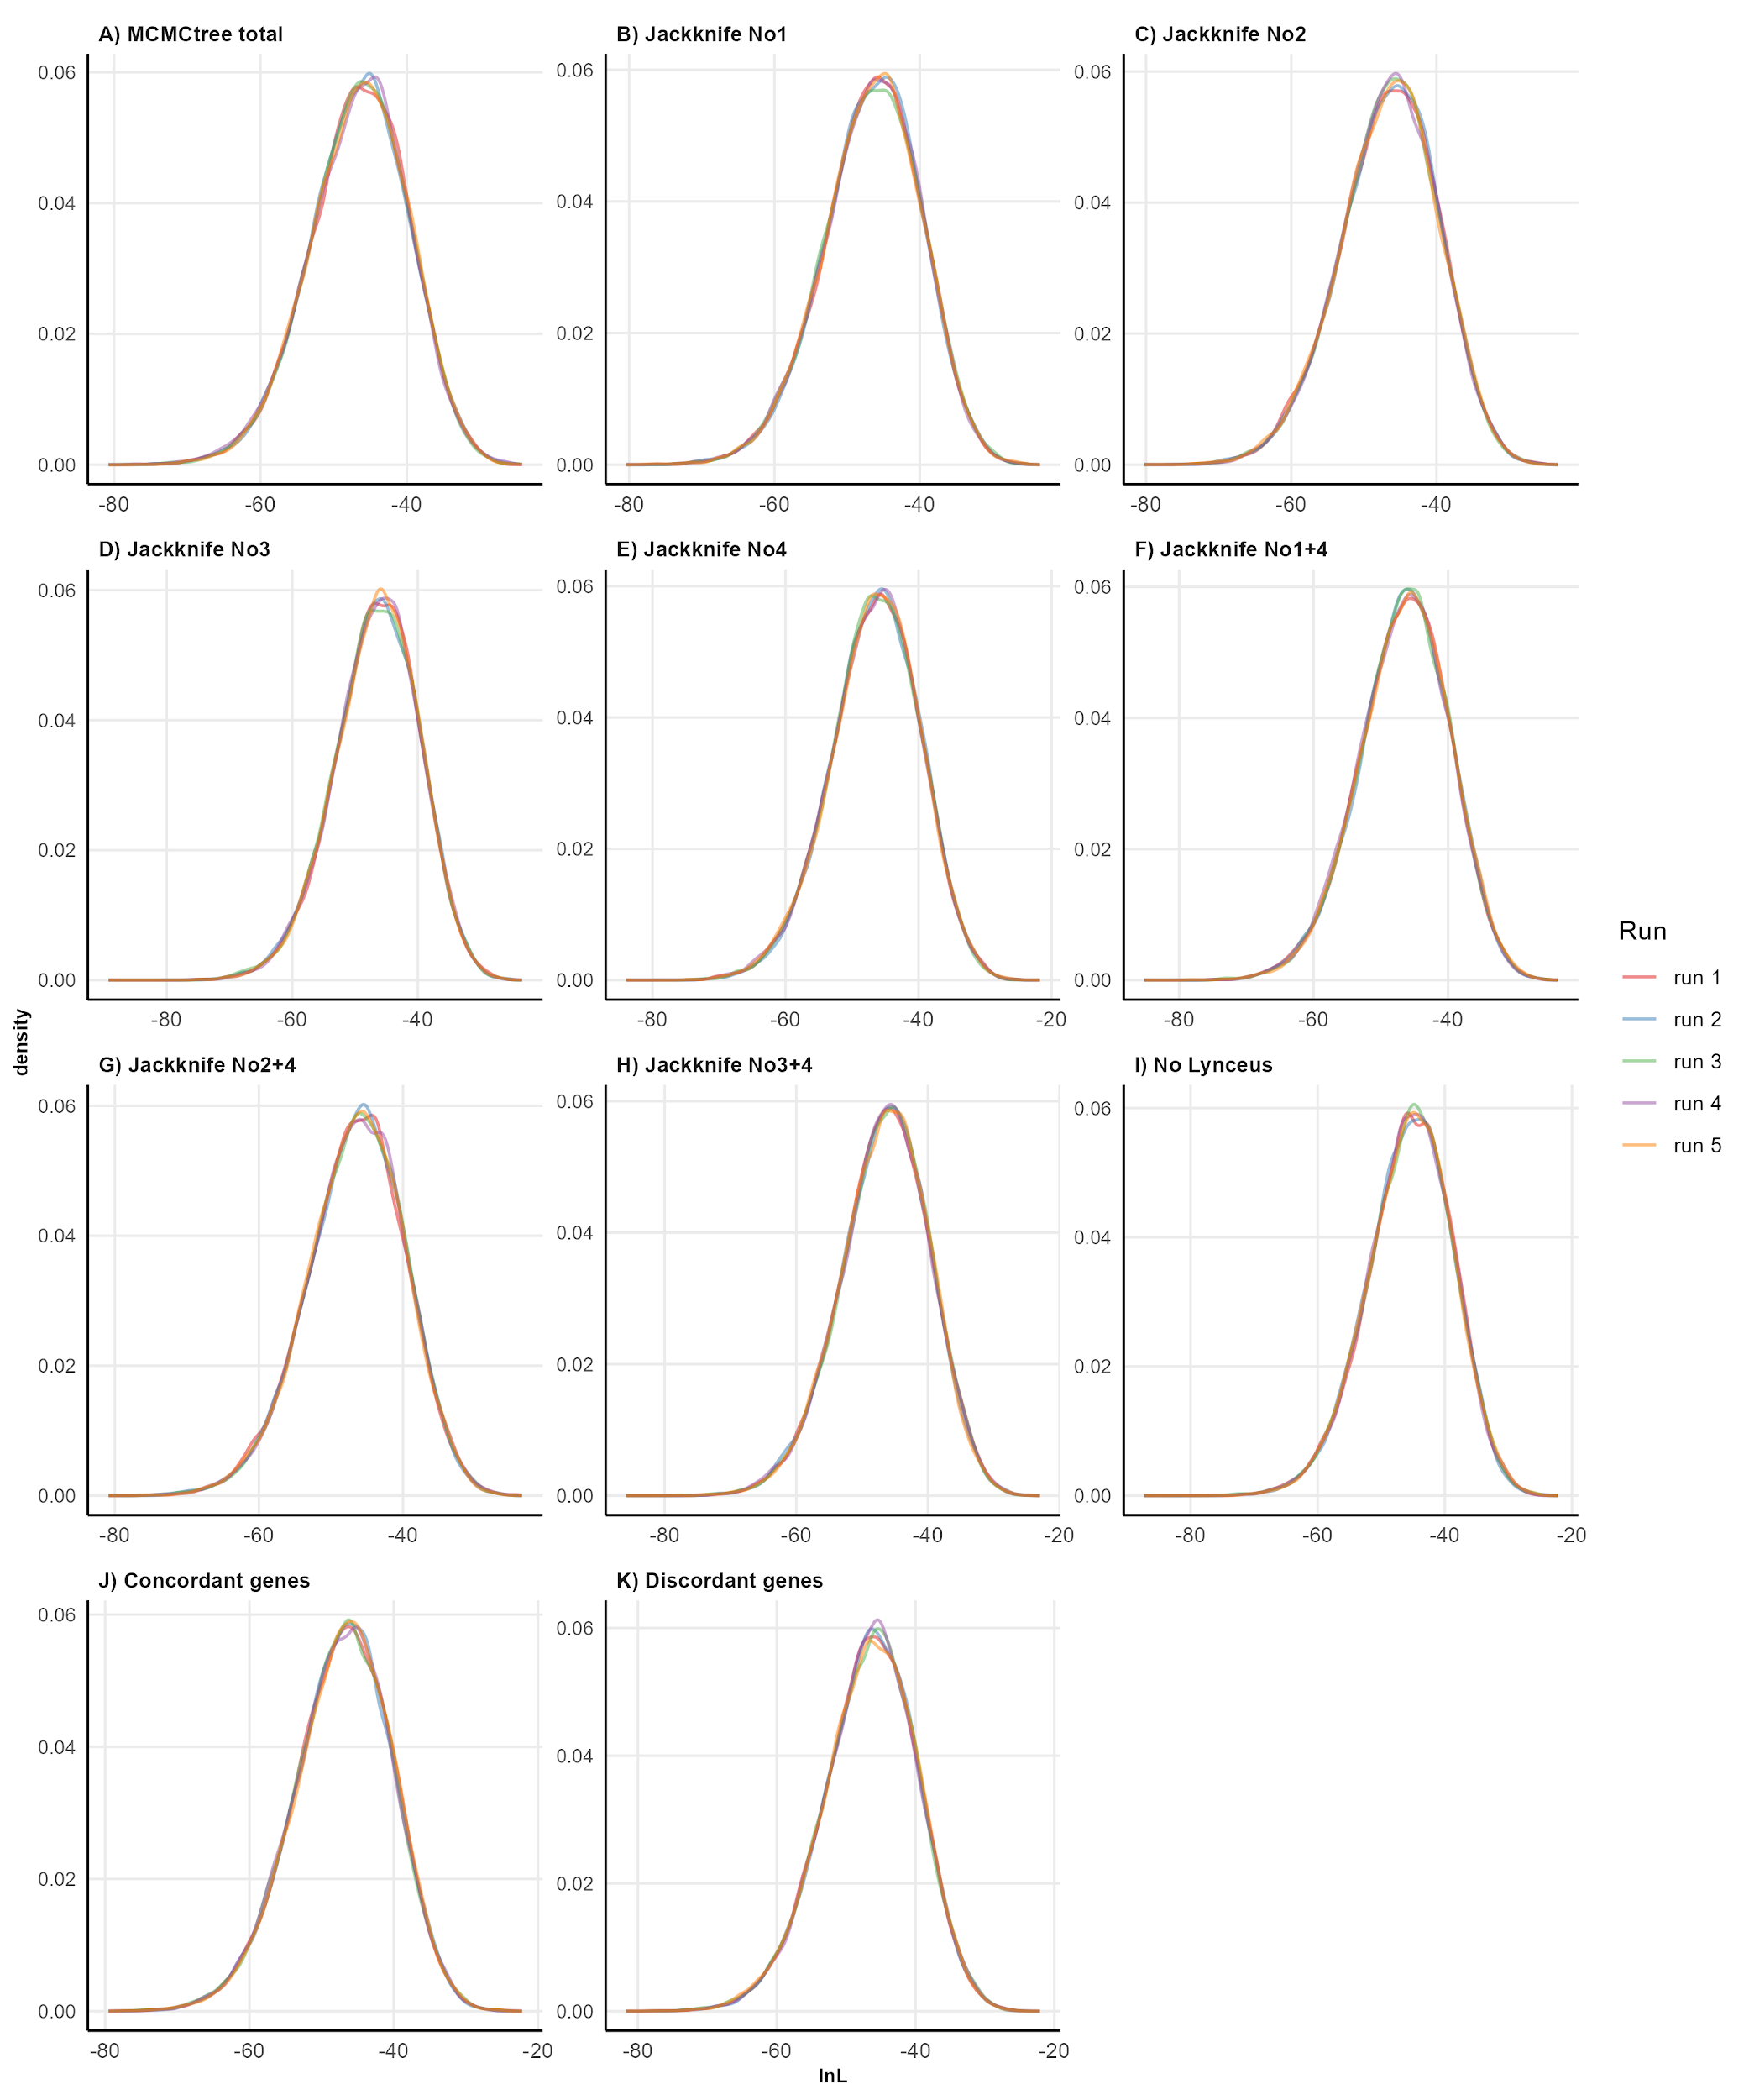

**SUPPLEMENTARY FIGURE S1.** Tracer plots of lnL values for each MCMCtree analysis. Numbers for jackknife resampling are the same as in Fig. 1 and [Supp. Table S1](https://docs.google.com/spreadsheets/d/1oCFKZS3SYD_m4mJsSv9hDgdZeqQYHtmNbTfW5q1zphk/edit?gid=0#gid=0).

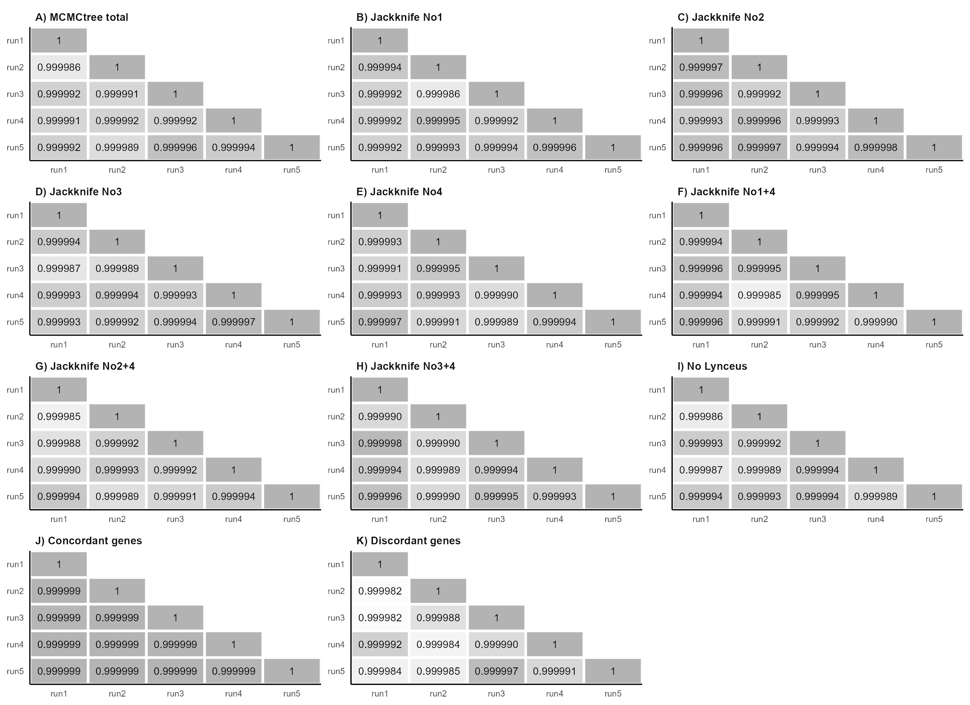

**SUPPLEMENTARY FIGURE S2.** Pairwise correlations of mean age estimates of the 5 runs for each MCMCtree analysis. Numbers of jackknife resampling are the same as in Fig. 1 and [Supp. Table S1](https://docs.google.com/spreadsheets/d/1oCFKZS3SYD_m4mJsSv9hDgdZeqQYHtmNbTfW5q1zphk/edit?gid=0#gid=0).

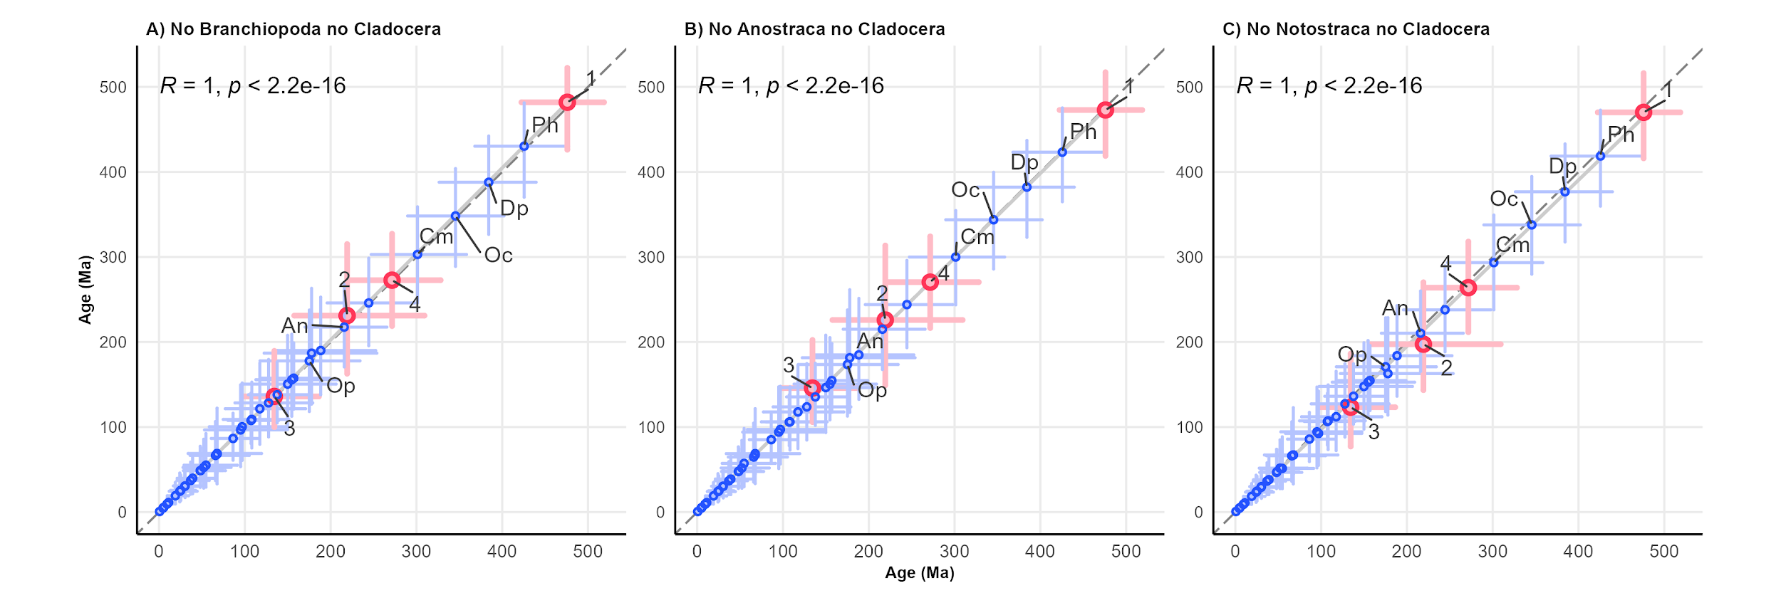**SUPPLEMENTARY FIGURE S3.** Correlations of age estimates between the timetree calibrated with all 5 age priors ([Table 1](https://docs.google.com/spreadsheets/d/1oCFKZS3SYD_m4mJsSv9hDgdZeqQYHtmNbTfW5q1zphk/edit?gid=0#gid=0)) and timetrees calibrated using the joint jackknife resampling of age priors (two nodes each time). Error bars are shown for each estimate. Red points indicate calibration nodes and numbers are the same as in Fig. 1 and [Table 1](https://docs.google.com/spreadsheets/d/1oCFKZS3SYD_m4mJsSv9hDgdZeqQYHtmNbTfW5q1zphk/edit?gid=0#gid=0). Dashed lines represent the bisector of the quadrant, while solid lines represent the linear regression of plotted data. The root node and the node of *Ischnura elegans* + *Sinella curviseta* (outgroups) were removed. Pearson’s correlation coefficients (R) and the associated p-values are provided. Ph: Phyllopoda; Dp: Diplostraca; Oc: Onychocaudata; Cm: Cladoceromorpha; An: Anomopoda; Op: Onychopoda.

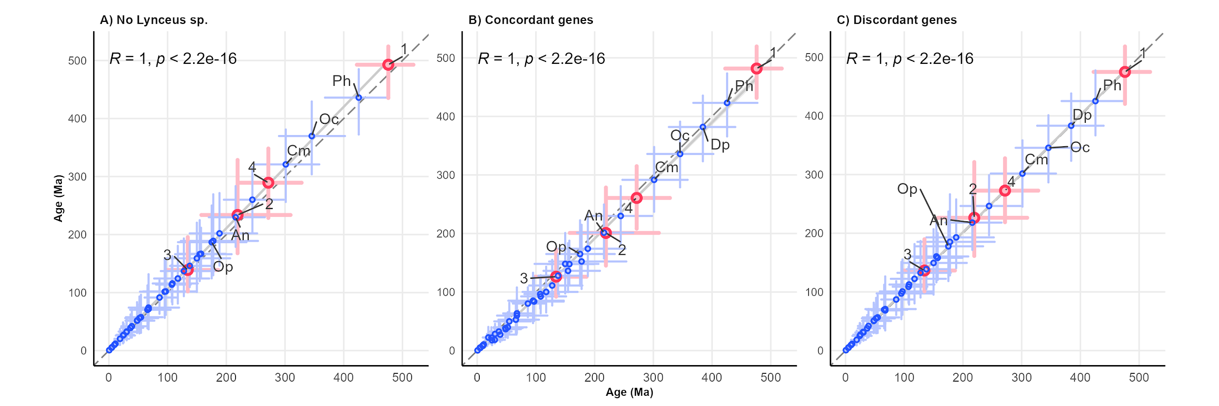

**SUPPLEMENTARY FIGURE S4.** Correlations of age estimates between the timetree calibrated with 5 calibrated with 5 age priors ([Table 1](https://docs.google.com/spreadsheets/d/1oCFKZS3SYD_m4mJsSv9hDgdZeqQYHtmNbTfW5q1zphk/edit?gid=0#gid=0)) and timetrees calibrated after phylogenetic trees built with different alignments. Error bars are shown for each estimate. Red points indicate calibration nodes and numbers are the same as in Fig. 1 and [Table 1](https://docs.google.com/spreadsheets/d/1oCFKZS3SYD_m4mJsSv9hDgdZeqQYHtmNbTfW5q1zphk/edit?gid=0#gid=0). The root node and the node of *Ischnura elegans* + *Sinella curviseta* (outgroups) were removed. Pearson’s correlation coefficients (R) and the associated p-values are shown. Ph: Phyllopoda; Dp: Diplostraca; Oc: Onychocaudata; Cm: Cladoceromorpha; An: Anomopoda; Op: Onychopoda.

# SUPPLEMENTARY TABLES

| **Species** | **ID** | **Subclass** | **Superorder** | **Group** | **Order** | **Family** | **GenBank Accession Number** | **BUSCO statistics** | **BUSCO genes for phylogenomics** | **Reference** |
| --- | --- | --- | --- | --- | --- | --- | --- | --- | --- | --- |
| *Ischnura elegans* | Iele | Outgroup | Outgroup | Outgroup | Outgroup | Outgroup | [GCA_921293095.1](https://www.ncbi.nlm.nih.gov/datasets/genome/GCA_921293095.1/) | C:98.0%[S:97.4%,D:0.6%], F:0.9%, M:1.1% | 134 | Price *et al*., 2022 |
| *Sinella curviseta* | Scur | Outgroup | Outgroup | Outgroup | Outgroup | Outgroup | [GCA_004115045.3](https://www.ncbi.nlm.nih.gov/datasets/genome/GCA_004115045.3/) | C:96.3%[S:93.7%,D:2.6%], F:1.3%, M:2.4% | 129 | Zhang *et al*., 2019 |
| *Branchinecta lindahli* | Blin | Sarsotraca | - | - | Anostraca | Branchinectidae | [GCA_023053555.1](https://www.ncbi.nlm.nih.gov/datasets/genome/GCA_023053555.1/) | C:90.8%[S:90.5%,D:0.3%], F:3.5%, M:5.7% | 131 | Kieran Blair *et al*., 2023a |
| *Branchinecta lynchi* | Blyn | Sarsotraca | - | - | Anostraca | Branchinectidae | [GCA_023053575.1](https://www.ncbi.nlm.nih.gov/datasets/genome/GCA_023053575.1/) | C:90.1%[S:89.4%,D:0.7%], F:4.0%, M:5.9% | 130 | Kieran Blair *et al*., 2023b |
| *Artemia franciscana* | Afr1 | Sarsotraca | - | - | Anostraca | Artemiidae | [Korea Polar Research Institute](https://antagen.kopri.re.kr/project/genome_info_iframe.php?Code=AF01) | C:66.4%[S:62.5%,D:3.9%], F:20.5%, M:13.1% | 105 | NA |
| *Branchinella herrodi* | Bher | Sarsotraca | - | - | Anostraca | Thamnocephalidae | [SRR4113492](https://trace.ncbi.nlm.nih.gov/Traces?run=SRR4113492) | C:75.2%[S:73.4%,D:1.8%], F:14.3%, M:10.5% | 123 | Schwentner *et al*., 2018 |
| *Streptocephalus sp.* | Stsp | Sarsotraca | - | - | Anostraca | Streptocephalidae | [SRR5140122](https://trace.ncbi.nlm.nih.gov/Traces?run=SRR5140122) | C:21.7%[S:21.5%,D:0.2%], F:36.5%, M:41.8% | 90 | Schwentner *et al*., 2018 |
| *Thamnocephalus platyurus* | Tpla | Sarsotraca | - | - | Anostraca | Thamnocephalidae | [SRR5140150](https://trace.ncbi.nlm.nih.gov/Traces?run=SRR5140150) | C:35.4%[S:35.1%,D:0.3%], F:37.4%, M:27.2% | 118 | Schwentner *et al*., 2018 |
| *Triops cancriformis* ESP | Tces | Phyllopoda | Calmanostraca | - | Notostraca | Triopsidae | [GCA_022832265.1](https://www.ncbi.nlm.nih.gov/datasets/genome/GCA_022832265.1/) | C:96.2%[S:87.8%,D:8.4%], F:2.3%, M:1.5% | 124 | Luchetti *et al*., 2021 |
| *Triops cancriformis* ITA | Tcit | Phyllopoda | Calmanostraca | - | Notostraca | Triopsidae | [GCA_022832245.1](https://www.ncbi.nlm.nih.gov/datasets/genome/GCA_022832245.1/) | C:96.6%[S:96.3%,D:0.3%], F:2.4%, M:1.0% | 134 | Luchetti *et al*., 2021 |
| *Triops cancriformis* JPN | Tcjp | Phyllopoda | Calmanostraca | - | Notostraca | Triopsidae | [GCA_000981345.1](https://www.ncbi.nlm.nih.gov/datasets/genome/GCA_000981345.1/) | C:94.8%[S:94.7%,D:0.1%], F:3.8%, M:1.4% | 133 | Ikeda *et al*., 2015 |
| *Triops longicaudatus* | Tlon | Phyllopoda | Calmanostraca | - | Notostraca | Triopsidae | [GCA_022885665.1](https://www.ncbi.nlm.nih.gov/datasets/genome/GCA_022885665.1/) | C:97.3%[S:97.1%,D:0.2%], F:2.1%, M:0.6% | 134 | Luchetti *et al*., 2021 |
| *Lepidurus apus apus* | Lapu | Phyllopoda | Calmanostraca | - | Notostraca | Triopsidae | [GCA_022832285.1](https://www.ncbi.nlm.nih.gov/datasets/genome/GCA_022832285.1/) | C:97.6%[S:96.6%,D:1.0%], F:1.6%, M:0.8% | 132 | Luchetti *et al*., 2021 |
| *Lepidurus arcticus* | Lart | Phyllopoda | Calmanostraca | - | Notostraca | Triopsidae | [GCA_003724045.1](https://www.ncbi.nlm.nih.gov/datasets/genome/GCA_003724045.1/) | C:97.5%[S:96.2%,D:1.3%], F:1.6%, M:0.9% | 133 | Savojardo *et al*., 2019 |
| *Lepidurus couesii* | Lcou | Phyllopoda | Calmanostraca | - | Notostraca | Triopsidae | [GCA_022832235.1](https://www.ncbi.nlm.nih.gov/datasets/genome/GCA_022832235.1/) | C:95.9%[S:90.6%,D:5.3%], F:2.7%, M:1.4% | 128 | Luchetti *et al*., 2021 |
| *Lepidurus cryptus* | Lcry | Phyllopoda | Calmanostraca | - | Notostraca | Triopsidae | [SRR5140152](https://trace.ncbi.nlm.nih.gov/Traces?run=SRR5140152) | C:62.5%[S:62.0%,D:0.5%], F:25.8%, M:11.7% | 127 | Schwentner *et al*., 2018 |
| *Lepidurus packardi* | Lpac | Phyllopoda | Calmanostraca | - | Notostraca | Triopsidae | [GCA_023053545.1](https://www.ncbi.nlm.nih.gov/datasets/genome/GCA_023053545.1/) | C:97.2%[S:96.7%,D:0.5%], F:1.4%, M:1.4% | 134 | Kieran Blair *et al*., 2022 |
| *Lepidurus apus lubbocki* | Lubb | Phyllopoda | Calmanostraca | - | Notostraca | Triopsidae | [GCA_003723985.1](https://www.ncbi.nlm.nih.gov/datasets/genome/GCA_003723985.1/) | C:97.8%[S:89.2%,D:8.6%], F:1.4%, M:0.8% | 124 | Savojardo *et al*., 2019 |
| *Lynceus sp.* | Lysp | Phyllopoda | Diplostraca | ‘Conchostraca’ | Laevicaudata | Lynceidae | [SRR5140145](https://trace.ncbi.nlm.nih.gov/Traces?run=SRR5140145) | C:65.7%[S:65.2%,D:0.5%], F:23.6%, M:10.7% | 125 | Schwentner *et al*., 2018 |
| *Cyzicus pilosus* | Cpil | Phyllopoda | Diplostraca | ‘Conchostraca’ | Spinicaudata | Cyzicidae | [SRR5140139](https://trace.ncbi.nlm.nih.gov/Traces?run=SRR5140139) | C:63.9%[S:61.6%,D:2.3%], F:24.8%, M:11.3% | 124 | Schwentner *et al*., 2018 |
| *Ozestheria rubra* | Orub | Phyllopoda | Diplostraca | ‘Conchostraca’ | Spinicaudata | Cyzicidae | [SRR4113504](https://trace.ncbi.nlm.nih.gov/Traces?run=SRR4113504) | C:62.4%[S:60.9%,D:1.5%], F:25.9%, M:11.7% | 127 | Schwentner *et al*., 2018 |
| *Ozestheria sp.* | Ozsp | Phyllopoda | Diplostraca | ‘Conchostraca’ | Spinicaudata | Cyzicidae | [SRR5140151](https://trace.ncbi.nlm.nih.gov/Traces?run=SRR5140151) | C:23.8%[S:23.7%,D:0.1%], F:32.6%, M:43.6% | 100 | Schwentner *et al*., 2018 |
| *Eocyzicus sp.* | Eosp | Phyllopoda | Diplostraca | ‘Conchostraca’ | Spinicaudata | Eocyzicidae | [SRR5140111](https://trace.ncbi.nlm.nih.gov/Traces?run=SRR5140111) | C:79.1%[S:76.7%,D:2.4%], F:14.7%, M:6.2% | 128 | Schwentner *et al*., 2018 |
| *Eoleptestheria cf. ticinensis* | Etic | Phyllopoda | Diplostraca | ‘Conchostraca’ | Spinicaudata | Leptestheriidae | [SRR5140141](https://trace.ncbi.nlm.nih.gov/Traces?run=SRR5140141) | C:71.1%[S:69.0%,D:2.1%], F:19.1%, M:9.8% | 130 | Schwentner *et al*., 2018 |
| *Leptestheria dahalacensis* | Ldah | Phyllopoda | Diplostraca | ‘Conchostraca’ | Spinicaudata | Leptestheriidae | [GCA_022114935.1](https://www.ncbi.nlm.nih.gov/datasets/genome/GCA_022114935.1/) | C:92.9%[S:90.1%,D:2.8%], F:3.4%, M:3.7% | 128 | Luchetti *et al*., 2021 |
| *Eulimnadia texana* | Etex | Phyllopoda | Diplostraca | ‘Conchostraca’ | Spinicaudata | Limnadiidae | [GCA_002872375.1](https://www.ncbi.nlm.nih.gov/datasets/genome/GCA_002872375.1/) | C:98.8%[S:94.4%,D:4.4%], F:0.7%, M:0.5% | 131 | Baldwin-Brown *et al*., 2018 |
| *Limnadopsis birchii* | Lbir | Phyllopoda | Diplostraca | ‘Conchostraca’ | Spinicaudata | Limnadiidae | [SRR5140136](https://trace.ncbi.nlm.nih.gov/Traces?run=SRR5140136) | C:40.0%[S:38.2%,D:1.8%], F:38.5%, M:21.5% | 111 | Schwentner *et al*., 2018 |
| *Limnadopsis parvispinus* | Lpar | Phyllopoda | Diplostraca | ‘Conchostraca’ | Spinicaudata | Limnadiidae | [SRR5140106](https://trace.ncbi.nlm.nih.gov/Traces?run=SRR5140106) | C:34.1%[S:33.1%,D:1.0%], F:38.0%, M:27.9% | 120 | Schwentner *et al*., 2018 |
| *Metalimnadia sp.* | Mesp | Phyllopoda | Diplostraca | ‘Conchostraca’ | Spinicaudata | Limnadiidae | [SRR5140110](https://trace.ncbi.nlm.nih.gov/Traces?run=SRR5140110) | C:46.4%[S:45.1%,D:1.3%], F:35.1%, M:18.5% | 119 | Schwentner *et al*., 2018 |
| *Paralimnadia urukhai* | Puru | Phyllopoda | Diplostraca | ‘Conchostraca’ | Spinicaudata | Limnadiidae | [SRR5140109](https://trace.ncbi.nlm.nih.gov/Traces?run=SRR5140109) | C:67.3%[S:66.3%,D:1.0%], F:22.4%, M:10.3% | 131 | Schwentner *et al*., 2018 |
| *Cyclestheria hislopi* | C146 | Phyllopoda | Diplostraca | ‘Conchostraca’ | Cyclestherida | Cyclestheriidae | [SRR5140134](https://trace.ncbi.nlm.nih.gov/Traces?run=SRR5140134) | C:70.5%[S:69.6%,D:0.9%], F:20.9%, M:8.6% | 129 | Schwentner *et al*., 2018 |
| *Cyclestheria hislopi* | Chis | Phyllopoda | Diplostraca | ‘Conchostraca’ | Cyclestherida | Cyclestheriidae | [SRR5140140](https://trace.ncbi.nlm.nih.gov/Traces?run=SRR5140140) | C:81.1%[S:80.4%,D:0.7%], F:14.5%, M:4.4% | 130 | Schwentner *et al*., 2018 |
| *Sida crystallina* | Scry | Phyllopoda | Diplostraca | Cladocera | Ctenopoda | Sididae | [SRR5140104](https://trace.ncbi.nlm.nih.gov/Traces?run=SRR5140104) | C:82.0%[S:81.0%,D:1.0%], F:12.7%, M:5.3% | 134 | Schwentner *et al*., 2018 |
| *Polyphemus pediculus* | Pped | Phyllopoda | Diplostraca | Cladocera | Onychopoda | Polyphemidae | [SRR5140114](https://trace.ncbi.nlm.nih.gov/Traces?run=SRR5140114) | C:52.6%[S:51.9%,D:0.7%], F:30.6%, M:16.8% | 125 | Schwentner *et al*., 2018 |
| *Evadne cf. nordmanni* | Enor | Phyllopoda | Diplostraca | Cladocera | Onychopoda | Podonidae | [SRR5140118](https://trace.ncbi.nlm.nih.gov/Traces?run=SRR5140118) | C:66.1%[S:65.0%,D:1.1%], F:23.8%, M:10.1% | 125 | Schwentner *et al*., 2018 |
| *Podon leuckartii* | Pleu | Phyllopoda | Diplostraca | Cladocera | Onychopoda | Podonidae | [SRR5140133](https://trace.ncbi.nlm.nih.gov/Traces?run=SRR5140133) | C:63.5%[S:63.1%,D:0.4%], F:19.1%, M:17.4% | 126 | Schwentner *et al*., 2018 |
| *Bosmina sp.* | Bosp | Phyllopoda | Diplostraca | Cladocera | Anomopoda | Bosminidae | [SRR5140102](https://trace.ncbi.nlm.nih.gov/Traces?run=SRR5140102) | C:34.9%[S:34.6%,D:0.3%], F:34.7%, M:30.4% | 112 | Schwentner *et al*., 2018 |
| *Anchistropus emarginatus* | Aema | Phyllopoda | Diplostraca | Cladocera | Anomopoda | Chydoridae | [SRR5140156](https://trace.ncbi.nlm.nih.gov/Traces?run=SRR5140156) | C:90.5%[S:89.9%,D:0.6%], F:6.3%, M:3.2% | 134 | Schwentner *et al*., 2018 |
| *Eurycercus cf. lamellatus* | Elam | Phyllopoda | Diplostraca | Cladocera | Anomopoda | Eurycercidae | [SRR5140146](https://trace.ncbi.nlm.nih.gov/Traces?run=SRR5140146) | C:80.5%[S:79.5%,D:1.0%], F:13.2%, M:6.3% | 128 | Schwentner *et al*., 2018 |
| *Moina sp.* | Mosp | Phyllopoda | Diplostraca | Cladocera | Anomopoda | Moinidae | [SRR5140125](https://trace.ncbi.nlm.nih.gov/Traces?run=SRR5140125) | C:91.0%[S:89.6%,D:1.4%], F:6.2%, M:2.8% | 128 | Schwentner *et al*., 2018 |
| Macrothricidae sp. | Masp | Phyllopoda | Diplostraca | Cladocera | Anomopoda | Macrothricidae | [SRR5140158](https://trace.ncbi.nlm.nih.gov/Traces?run=SRR5140158) | C:84.3%[S:83.6%,D:0.7%], F:11.4%, M:4.3% | 133 | Schwentner *et al*., 2018 |
| *Ceriodaphnia quadrangula* | Cqua | Phyllopoda | Diplostraca | Cladocera | Anomopoda | Daphniidae | [SRR5140137](https://trace.ncbi.nlm.nih.gov/Traces?run=SRR5140137) | C:61.5%[S:59.6%,D:1.9%], F:26.6%, M:11.9% | 125 | Schwentner *et al*., 2018 |
| *Daphnia galeata* | Dgal | Phyllopoda | Diplostraca | Cladocera | Anomopoda | Daphniidae | [GCA_918697745.1](https://www.ncbi.nlm.nih.gov/datasets/genome/GCA_918697745.1/) | C:95.2%[S:94.2%,D:1.0%], F:1.5%, M:3.3% | 130 | Nickel *et al*., 2021 |
| *Daphnia magna* | Dmag | Phyllopoda | Diplostraca | Cladocera | Anomopoda | Daphniidae | [GCF_003990815.1](https://www.ncbi.nlm.nih.gov/datasets/genome/GCF_003990815.1/) | C:98.6%[S:94.4%,D:4.2%], F:0.6%, M:0.8% | 130 | Lee *et al*., 2019 |
| *Daphnia pulicaria* | Dpli | Phyllopoda | Diplostraca | Cladocera | Anomopoda | Daphniidae | [GCA_021234035.2](https://www.ncbi.nlm.nih.gov/datasets/genome/GCA_021234035.2/) | C:98.8%[S:97.2%,D:1.6%], F:0.7%, M:0.5% | 131 | Wersebe *et al*., 2023 |
| *Daphnia pulex* | Dpul | Phyllopoda | Diplostraca | Cladocera | Anomopoda | Daphniidae | [GCA_000187875.1](https://www.ncbi.nlm.nih.gov/datasets/genome/GCA_000187875.1/) | C:98.1%[S:97.9%,D:0.2%], F:0.6%, M:1.3% | 132 | Colbourne *et al*., 2011 |
| *Scapholeberis cf. mucronata* | Smuc | Phyllopoda | Diplostraca | Cladocera | Anomopoda | Daphniidae | [SRR5140113](https://trace.ncbi.nlm.nih.gov/Traces?run=SRR5140113) | C:77.5%[S:77.4%,D:0.1%], F:14.9%, M:7.6% | 130 | Schwentner *et al*., 2018 |
| *Simocephalus vetulus* | Svet | Phyllopoda | Diplostraca | Cladocera | Anomopoda | Daphniidae | [SRR5140138](https://trace.ncbi.nlm.nih.gov/Traces?run=SRR5140138) | C:81.4%[S:81.1%,D:0.3%], F:13.0%, M:5.6% | 133 | Schwentner *et al*., 2018 |

**SUPPLEMENTARY TABLE S1.** Genomes and transcriptomes used in the phylogenetic analysis of Branchiopoda, including the two Hexapoda outgroups. For each sample, ID codes used in the analyses, taxonomic information, GenBank accession numbers (or source website), BUSCO statistics, and the number of BUSCO genes used in the ML tree inference, are reported.

|  |  |  |  |  |  |  |  |  |  |  |  |  |
| --- | --- | --- | --- | --- | --- | --- | --- | --- | --- | --- | --- | --- |
|  | Sun *et al*., 2016 | | Uozomi *et al*., 2021 | | Xu *et al*., 2021 | | Van Damme *et al*., 2022 | | Bernot *et al*., 2023 | | This work | |
| **Clade** | **Date** | **95% CI** | **Date** | **95% CI** | **Date** | **95% CI** | **Date** | **95% CI** | **Date** | **95% CI** | **Date** | **95% CI** |
| Branchiopoda (1) | 495.0 | 478.0 – 512.0 | 534.5 | N/A | N/A | N/A | 520.98 | 520.92 – 521 | 450.0 | 401.4 – 503.9 | 475.89 | 422.39 – 518.68 |
| Anostraca (2) | 310.0a | 218.0 – 402.0 | 142.1 | N/A | N/A | N/A | N/A | N/A | N/A | N/A | 219.22 | 157.64 – 309.38 |
| Phyllopoda | 465.0 | 448.0 – 480.0 | 496.0 | N/A | N/A | N/A | 465.83 | 462.52 – 469.06 | 370.0 | 277.7 – 447.8 | 425.60 | 368.05 – 477.31 |
| Notostraca (3) | N/A | N/A | 51.7b | N/A | N/A | N/A | 121.8 | N/A | N/A | N/A | 134.38 | 98.73 – 186.37 |
| Diplostraca | 450.0 | 430.0 – 460.0 | 419.1 | N/A | N/A | N/A | 454.87 | 451.59 – 458.23 | N/A | N/A | 384.30 | 326.46 – 439.52 |
| Onychocaudata | 465.5 | 416 – 515 | 376.2 | N/A | N/A | N/A | 391.58 | 388.57 – 394.51 | 240.0 | 147.3 – 344.3 | 345.52 | 289.72 – 402.12 |
| Spinicaudata | N/A | N/A | 170.6 | N/A | N/A | N/A | N/A | N/A | N/A | N/A | 188.43 | 137.72 – 252.53 |
| Cladoceromorpha | N/A | N/A | 305.9 | N/A | 340 | N/A | 361.78 | 358.94 – 364.59 | N/A | N/A | 301.28 | 247.31 – 358.37 |
| Cyclestherida | N/A | N/A | N/A | N/A | N/A | N/A | N/A | N/A | N/A | N/A | 67.58 | 33.84 – 119.50 |
| Cladocera (4) | N/A | N/A | 261.5 | N/A | 299 | N/A | 325.06 | 322.7 – 327.51 | N/A | N/A | 271.60 | 219.48 – 328.25 |
| Anomopoda | N/A | N/A | 199.1 | N/A | 250 | N/A | 263.7 | 261.78 – 265.71 | N/A | N/A | 244.43 | 195.88 – 297.86 |
| Onychopoda | N/A | N/A | N/A | N/A | 235 | N/A | 272.45 | 269.73 – 275.91 | N/A | N/A | 175.15 | 117.72 – 234.24 |

**SUPPLEMENTARY TABLE S2.** Age estimates for the main Branchiopoda clades as obtained in this work and in previous analyzes. Where possible, 95% confidence intervals (95% CI) are reported. a: The calibration refers to Artemiidae + Thamnocephalidae + Streptocephalidae, and lacks Branchinectidae. b: The calibration refers to the genus *Triops*.