SUPPLEMENTARY MATERIALS

List of supplementary materials
Supplementary file 1 – Alignment of COI sequences of specimens of the Megascops atricapilla / watsonii complex analyzed in this study.

Supplementary file 2 – Alignment of cytb sequences of specimens of the Megascops atricapilla / watsonii complex analyzed in this study.

Supplementary file 3 – Alignment of ND2 sequences of specimens of the Megascops atricapilla / watsonii complex analyzed in this study.

Figure S1. Biogeographical areas considered in this study used in ancestral areas reconstructions: (AN) Andes; (GS) Guianan Shield; (BS) Brazilian Shield; (CP) Pernambuco Center; (AF) Atlantic Forest (south of São Francisco River); (NB) Northern Amazonian Sedimentary Basin; and (SB) Southern Amazonian Sedimentary Basin. Modified from Conn and Mirabello (2007).

Figure S2. Haplotype networks for the six molecular markers used in the study. Letters .a - .f in the legend refer respectively to clades A-F.

Table S1. GenBank accession numbers associated with gene sequences of specimens used in this study. See Appendix for detailed information on each specimen.

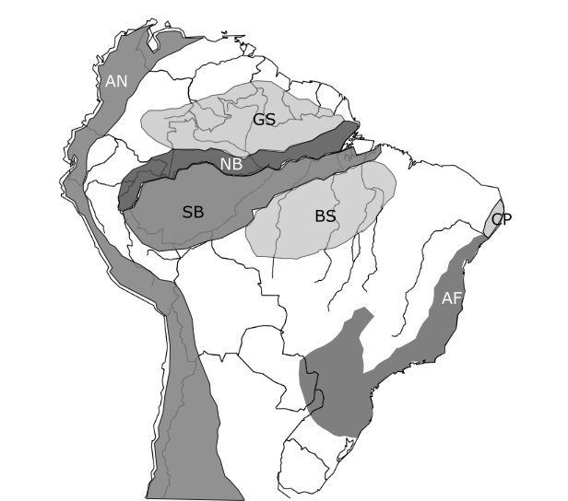

Figure S1.
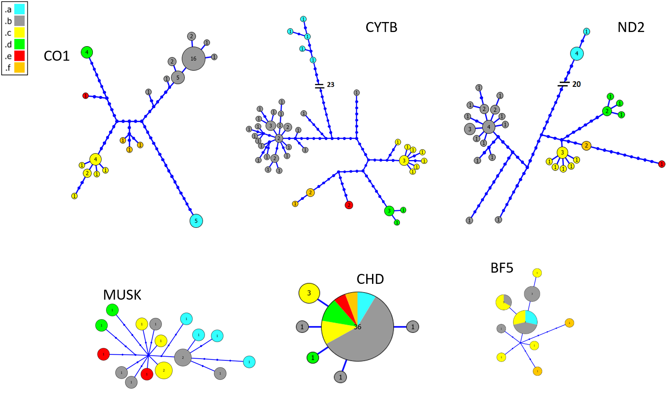

Figure S2.

Table S1. GenBank accession numbers associated with gene sequences of specimens used in this study. See Appendix for detailed information on Megascops atricapilla-M. watsonii specimens. Detailed information on specimens belonging to the outgroup can be found in Dantas et al. (2016).
Voucher / tissue # ¹ | Taxon | GenBank accession numbers
 |  | COI | Cytb | ND2 | BF5 | CHD | MUSK
ANSP 188291 | Megascops watsonii | MW477385 | MW560400 | MW588819 | MW479482 | - | MW475301
ANSP 21937 | Megascops watsonii | MW477386 | MW560401 | MW588820 | - | MW588858 | MW475302
ANSP 2445 | Megascops watsonii | - | - | - | - | - | -
LSUMZ B20185 | Megascops watsonii | MW477388 | MW560403 | MW588822 | - | MW588860 | MW475304
MPEG 66635 | Megascops watsonii | KT799321 | KT799277 | KT799372 | KT799432; KT799433 | - | KT799523
NMNH 11476 | Megascops watsonii | MW477429 | MW560443 | MW588855 | - | MW588894 | MW475333
FMNH 456485 | Megascops usta | KT799320 | KT799276 | KT799371 | KT799431 | KT799470 | KT799521; KT799522
KUNHM 944 | Megascops usta | MW477387 | MW560402 | MW588821 | - | MW588859 | MW475303
LSUMZ B2829 | Megascops usta | MW477389 | MW560404 | MW588823 | MW479483 | - | MW475305
LSUMZ B2912 | Megascops usta | MW477390 | MW560405 | MW588824 | MW479484 | MW588861 | MW475306
LSUMZ B46287 | Megascops usta | MW477391 | MW560406 | MW588825 | MW479485 | MW588862 | MW475307
LSUMZ B947 | Megascops usta | MW477392 | MW560407 | MW588826 | - | MW588863 | MW475308
LSUMZ B9665 | Megascops usta | - | MW560408 | MW588827 | MW479486 | - | -
MPEG 57930 | Megascops usta | MW477393 | - | MW588828 | - | MW588864 | MW475309
MPEG 62429 | Megascops usta | MW477394 | MW560409 | MW588829 | MW479487 | MW588865 | MW475310
MPEG 67246 | Megascops usta | MW477395 | MW560410 | - | MW479488 | MW588866 | MW475311
MPEG 69086 | Megascops usta | MW477396 | MW560411 | MW588830 | - | MW588867 | MW475312
MPEG 70205 | Megascops usta | MW477397 | MW560412 | MW588831 | MW479489 | MW588868 | MW475313
MPEG 70206 | Megascops usta | MW477398 | MW560413 | MW588832 | - | MW588869 | MW475314
MPEG 70660 | Megascops usta | KT799323 | KT799279 | KT799374 | KT799435 | KT799472; KT799473 | KT799526; KT799527
MPEG 70663 | Megascops usta | MW477405 | MW560418 | MW588838 | MW479496; MW479497 | MW588876 | MW475319
MPEG 70987 | Megascops usta | MW477409 | MW560422 | MW588842 | - | MW588880 | MW475321
MPEG 70997 | Megascops usta | MW477410 | MW560423 | MW588843 | MW479500 | MW588881 | MW475322
MPEG 71378 | Megascops usta | MW477413 | MW560426 | MW588845 | - | MW588884 | MW475325
MPEG 72556 | Megascops usta | MW477414 | MW560427 | MW588846 | - | MW588885 | -
MPEG 72557 | Megascops usta | MW477415 | MW560428 | MW588847 | - | - | -
MPEG 72619 | Megascops usta | MW477416 | MW560429 | - | - | MW588886 | -
MPEG 72973 | Megascops usta | MW477417 | MW560430 | MW588848 | - | MW588887 | -
MPEG 74006 | Megascops usta | MW477418 | MW560431 | MW588849 | MW479503 | - | MW475326
MPEG 74094 | Megascops usta | MW477419 | MW560432 | - | MW479504 | - | MW475327
MPEG 74096 | Megascops usta | MW477420 | MW560433 | - | MW479505 | - | MW475328
MPEG 77180 | Megascops usta | - | MW560436 | MW588852 | MW479507 | MW588890 | -
MPEG 77825 | Megascops usta | MW477423 | MW560437 | - | - | MW588891 | -
MPEG 81521 | Megascops usta | MW477424 | MW560438 | MW588853 | MW479479 | - | -
MZUSP 88058 | Megascops usta | MW477426 | MW560440 | MW588854 | MW479509 | MW588892 | MW475330
MZUSP JF297 | Megascops usta | MW477427 | MW560441 | - | MW479480 | MW588893 | MW475331
MZUSP JF754 | Megascops usta | MW477428 | MW560442 | - | MW479481 | - | MW475332
MPEG 70627 | Megascops stangiae | MW477403 | MW560416 | MW588836 | MW479494 | MW588874 | MW475317
MPEG 70632 | Megascops stangiae | MW477404 | MW560417 | MW588837 | MW479495 | MW588875 | MW475318
MPEG 70678 | Megascops stangiae | MW477406 | MW560419 | MW588839 | MW479498 | MW588877 | MW475320
MPEG 70845 | Megascops stangiae | MW477407 | MW560420 | MW588840 | MW479499 | MW588878 | -
MPEG 70846 | Megascops stangiae | MW477408 | MW560421 | MW588841 | - | MW588879 | -
MPEG 71331 | Megascops stangiae | MW477411 | MW560424 | - | MW479501 | MW588882 | MW475323
MPEG 71332 | Megascops stangiae | MW477412 | MW560425 | MW588844 | MW479502 | MW588883 | MW475324
MZUSP 83559 | Megascops stangiae | MW477425 | MW560439 | - | MW479508 | - | MW475329
NMNH 6991 | Megascops stangiae | MW477430 | MW560444 | MW588856 | - | - | -
NMNH 7020 | Megascops stangiae | MW477431 | MW560445 | MW588857 | MW479510 | - | -
MPEG 70268 | Megascops ater | MW477399 | MW560414 | MW588833 | MW479490; MW479491 | MW588870 | MW475315
MPEG 70433 | Megascops ater | MW477400 | MW560415 | MW588834 | MW479492; MW479493 | MW588871 | MW475316
MPEG 70434 | Megascops ater | KT799322 | KT799278 | KT799373 | KT799434 | KT799471 | KT799524; KT799525
MPEG 76937 | Megascops ater | MW477421 | MW560434 | MW588850 | - | MW588888 | -
MPEG 76957 | Megascops ater | MW477422 | MW560435 | MW588851 | - | MW588889 | -
MPEG 70437 | Megascops alagoensis | MW477401 | MW560398 | - | - | MW588872 | -
MPEG 70438 | Megascops alagoensis | MW477402 | MW560399 | MW588835 | - | MW588873 | -
KUNHM 157 | Megascops atricapilla | KT799284 | KT799239 | KT799335 | KT799381; KT799382 | KT799440 | KT799481
MPEG 64808 | Megascops atricapilla | MW477384 | MW560397 | - | - | - | -
MZUSP BA226 | Megascops atricapilla | KT799285 | KT799240 | KT799336 | KT799383 | KT799441 | KT799482; KT799483
KUNHM 2092 | Megascops guatemalae | KT799296 | KT799251 | KT799348 | KT799399; KT799400 | KT799452 | KT799494; KT799495
ANSP 16806 | Megascops roboratus | KT799315 | KT799271 | KT799366 | - | KT799467 | -
MPEG 72106 | Megascops sanctaecatarinae | KT799317 | KT799273 | KT799368 | KT799425; KT799426 | KT799468 | -

¹ Institution codes: Academy of Natural Sciences of Drexel University, Philadelphia, USA (ANSP); Instituto Nacional de Pesquisas da Amazônia, Manaus, Brazil (INPA); Louisiana State University Museum of Natural Science, Baton Rouge, USA (LSUMZ); Museu Paraense Emílio Goeldi, Belém, Brazil (MPEG), and the Smithsonian Institution National Museum of Natural History (USNM).

