Supplementary Material

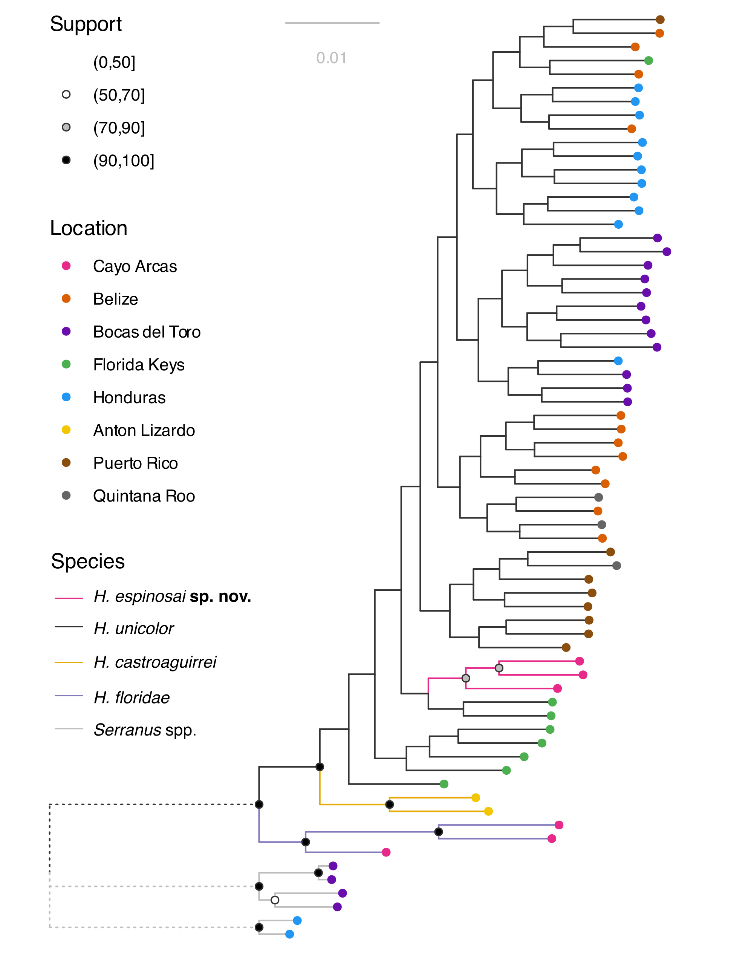
FIGURE S1. Optimal maximum likelihood phylogeny of Hypoplectrus species, and populations, considered in this study according to IQ-TREE (ln L = –675689.891). The analysis was based on approximately 91,000 genome-wide SNPs and the GTR+ASC model. The tree was rooted with three species in the genus Serranus. Support symbols at the nodes indicate nonparametric bootstrap estimates based on 200 replicates.
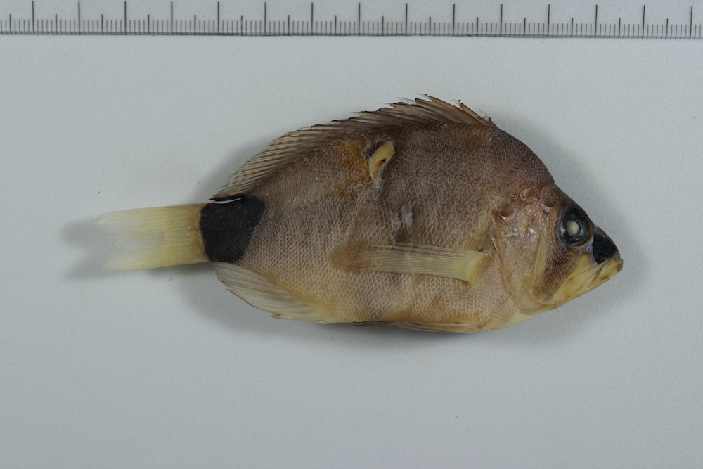
FIGURE S2. Preserved holotype UMSNH CPUM 14398 Hypoplectrus espinosai sp. nov. 90.4 mm SL, collected in Cayo Arcas, in the southern Gulf of Mexico (20°12′14′′N, 91°58′15′′W) on 24 June 2018.

TABLE S1. Fish species identity, collection date and location, and European Nucleotide Archive (ENA) accession numbers of samples used in this study. NA = precise coordinates and/or dates are unknown; Mex. = Mexico; Pan. = Panama.
Sample ID | Species | Location | Date | Latitude | Longitude | Accession
62555 | H. espinosai | Cayo Arcas, Mex. | 24.06.2018 | 20.20394 | −91.97077 | ERS20924495
62571 | H. espinosai | Cayo Arcas, Mex. | 25.06.2018 | 20.20354 | –91.97664 | ERS20924502
62585 | H. espinosai | Cayo Arcas, Mex. | 25.06.2018 | 20.19568 | –91.95947 | ERS20924506
54649 | H. castroaguirrei | Antón Lizardo, Mex. | 02.07.2013 | 19.15555 | –95.86390 | ERS20924481
54650 | H. castroaguirrei | Antón Lizardo, Mex. | 02.07.2013 | 19.15555 | –95.86390 | ERS20924482
62558 | H. floridae | Cayo Arcas, Mex. | 24.06.2018 | 20.20394 | –91.97077 | ERS20924497
62559 | H. floridae | Cayo Arcas, Mex. | 24.06.2018 | 20.20394 | –91.97077 | ERS20924498
62560 | H. floridae | Cayo Arcas, Mex. | 24.06.2018 | 20.20394 | –91.97077 | ERS20924499
13318 | H. unicolor | Quintana Roo, Mex. | 08.01.2007 | 20.45633 | –87.26217 | ERS20924418
18163 | H. unicolor | Belize | 25.07.2004 | 16.76528 | –88.14417 | ERS2619674
18261 | H. unicolor | Belize | 24.07.2004 | NA | NA | ERS2619675
18267 | H. unicolor | Belize | 24.07.2004 | NA | NA | ERS2619676
18274 | H. unicolor | Belize | 24.07.2004 | NA | NA | ERS2619677
18276 | H. unicolor | Belize | 25.07.2004 | 16.76528 | –88.14417 | ERS2619678
18420 | H. unicolor | Bocas del Toro, Pan. | 12.05.2004 | 10.23917 | –83.17306 | ERS2619698
18435 | H. unicolor | Bocas del Toro, Pan. | 23.06.2004 | 9.33278 | –82.25472 | ERS2619699
18439 | H. unicolor | Bocas del Toro, Pan. | 25.06.2004 | 9.33278 | –82.25472 | ERS2619700
18440 | H. unicolor | Bocas del Toro, Pan. | 25.06.2004 | 9.33278 | –82.25472 | ERS2619701
18441 | H. unicolor | Bocas del Toro, Pan. | 25.06.2004 | 9.33278 | –82.25472 | ERS2619702
18442 | H. unicolor | Bocas del Toro, Pan. | 08.07.2004 | 9.29833 | –82.28944 | ERS2619703
18445 | H. unicolor | Bocas del Toro, Pan. | 28.06.2004 | 9.33278 | –82.25472 | ERS2619704
18446 | H. unicolor | Bocas del Toro, Pan. | 29.06.2004 | 9.33278 | –82.25472 | ERS2619705
18447 | H. unicolor | Bocas del Toro, Pan. | 09.07.2004 | 9.28944 | –82.25889 | ERS2619706
18448 | H. unicolor | Bocas del Toro, Pan. | 28.06.2004 | 9.33278 | –82.25472 | ERS2619707
18450 | H. unicolor | Bocas del Toro, Pan. | 25.06.2004 | 9.33278 | –82.25472 | ERS2619708
18454 | H. unicolor | Bocas del Toro, Pan. | 30.06.2004 | 9.34806 | –82.26333 | ERS2619709
19881 | H. unicolor | Belize | 16.08.2005 | 16.70781 | –87.85981 | ERS2619679
20092 | H. unicolor | Belize | 15.08.2005 | 16.89364 | –88.12256 | ERS2619680
20120 | H. unicolor | Belize | 11.08.2005 | 16.80083 | –88.07889 | ERS2619681
20126 | H. unicolor | Belize | 12.08.2005 | 16.89364 | –88.12256 | ERS2619682
20128 | H. unicolor | Belize | 12.08.2005 | 16.89364 | –88.12256 | ERS2619683
20135 | H. unicolor | Belize | 12.08.2005 | 16.89364 | –88.12256 | ERS2619684
20149 | H. unicolor | Belize | 12.08.2005 | 16.89364 | –88.12256 | ERS2619685
20560 | H. unicolor | Honduras | 04.06.2006 | 15.95583 | –83.29306 | ERS2619686
20561 | H. unicolor | Honduras | 04.06.2006 | 15.95583 | –83.29306 | ERS2619687
20562 | H. unicolor | Honduras | 04.06.2006 | 15.95583 | –83.29306 | ERS2619688
20563 | H. unicolor | Honduras | 04.06.2006 | 15.95583 | –83.29306 | ERS2619689
20564 | H. unicolor | Honduras | 04.06.2006 | 15.95583 | –83.29306 | ERS2619690
20565 | H. unicolor | Honduras | 04.06.2006 | 15.95583 | –83.29306 | ERS2619691
20566 | H. unicolor | Honduras | 04.06.2006 | 15.95583 | –83.29306 | ERS2619692
20567 | H. unicolor | Honduras | 04.06.2006 | 15.95583 | –83.29306 | ERS2619693
20568 | H. unicolor | Honduras | 04.06.2006 | 15.95583 | –83.29306 | ERS2619694
20571 | H. unicolor | Honduras | 04.06.2006 | 15.95583 | –83.29306 | ERS2619695
20572 | H. unicolor | Honduras | 04.06.2006 | 15.95583 | –83.29306 | ERS2619696
27707 | H. unicolor | Quintana Roo, Mex. | 19.08.2010 | 20.84180 | –86.87781 | ERS20924468
27709 | H. unicolor | Quintana Roo, Mex. | 19.08.2010 | 20.84180 | –86.87781 | ERS20924469
PL17_134 | H. unicolor | Florida Keys, USA | 07.05.2017 | 24.84680 | –80.62296 | ERS14948448
PL17_135 | H. unicolor | Florida Keys, USA | 07.06.2017 | 24.75258 | –80.76065 | ERS14948455
PL17_136 | H. unicolor | Florida Keys, USA | 07.06.2017 | 24.75258 | –80.76065 | ERS14948452
PL17_137 | H. unicolor | Florida Keys, USA | 07.07.2017 | 24.73489 | –80.80080 | ERS14948453
PL17_138 | H. unicolor | Florida Keys, USA | 07.07.2017 | 24.73489 | –80.80080 | ERS14948451
PL17_140 | H. unicolor | Florida Keys, USA | 07.08.2017 | 24.80618 | –80.67677 | ERS14948456
PL17_141 | H. unicolor | Florida Keys, USA | 07.08.2017 | 24.80618 | –80.67677 | ERS14948457
PL17_143 | H. unicolor | Florida Keys, USA | 07.09.2017 | 24.81247 | –80.66971 | ERS14948454
PL17_55 | H. unicolor | Puerto Rico | 16.03.2017 | 17.95505 | –67.05325 | ERS14948485
PL17_63 | H. unicolor | Puerto Rico | 18.03.2017 | 17.97003 | –67.04642 | ERS14948487
PL17_66 | H. unicolor | Puerto Rico | 18.03.2017 | 17.97003 | –67.04642 | ERS14948459
PL17_67 | H. unicolor | Puerto Rico | 18.03.2017 | 17.93425 | –67.01878 | ERS14948493
PL17_70 | H. unicolor | Puerto Rico | 21.03.2017 | 17.89483 | –67.01714 | ERS14948489
PL17_73 | H. unicolor | Puerto Rico | 21.03.2017 | 17.89032 | –67.01794 | ERS14948491
PL17_74 | H. unicolor | Puerto Rico | 21.03.2017 | 17.89032 | –67.01794 | ERS14948492
PL17_77 | H. unicolor | Puerto Rico | 22.03.2017 | NA | NA | ERS14948488
28393 | S. tortugarum | Bocas del Toro, Pan. | 07.02.2017 | 9.30140 | –82.29410 | ERS4141276
Bocas16.3 | S. tortugarum | Bocas del Toro, Pan. | NA | NA | NA | ERS20924509
Bocas16.4 | S. tortugarum | Bocas del Toro, Pan. | NA | NA | NA | ERS20924510
s_tort_3 | S. tortugarum | Bocas del Toro, Pan. | NA | NA | NA | ERS4141278
20478 | S. tabacarius | Honduras | 06.06.2006 | 15.25000 | –82.61700 | ERS4141252
20480 | S. tabacarius | Honduras | 07.06.2006 | 15.25000 | –82.61700 | ERS20924457

