S1: Mean pairwise genetic distance matrix of the COI gene region, for the monophyletic clades of Chrysaora. Evolutionary analyses were conducted in MrBayes v4.1.3. All measures represented as mean ± standard error.

COI
 | Cyanea capillata | C. africana | C. fulgida | C. agulhensis sp. nov. | C. plocamia | C. pacifica | C. hysoscella | Chrysaora sp. Chesapeake | C. quinquecirrha
Cyanea capillata | 0,000 ± 0,000 | -
C. africana | 0,214 ± 0,016 | 0,002 ± 0,002 | -
C. fulgida | 0,196 ± 0,015 | 0,165 ± 0,015 | 0,002 ± 0,002 | -
C. agulhensis sp. nov. | 0,195 ± 0,015 | 0,171 ± 0,015 | 0,029 ± 0,006 | 0,008 ± 0,002 | -
C. plocamia | 0,196 ± 0,014 | 0,173 ± 0,016 | 0,074 ± 0,011 | 0,065 ± 0,009 | 0,004 ± 0,002 | -
C. pacifica | 0,201 ± 0,016 | 0,172 ± 0,014 | 0,165 ± 0,014 | 0,154 ± 0,014 | 0,164 ± 0,014 | 0,003 ± 0,002 | -
C. hysoscella | 0,191 ± 0,015 | 0,179 ± 0,016 | 0,074 ± 0,011 | 0,067 ± 0,010 | 0,09 ± 0,011 | 0,151 ± 0,013 | 0,001 ± 0,001 | -
Chrysaora sp. Chesapeake | 0,195 ± 0,015 | 0,171 ± 0,016 | 0,123 ± 0,013 | 0,119 ± 0,013 | 0,12 ± 0,013 | 0,169 ± 0,015 | 0,101 ± 0,013 | 0,005 ± 0,002 | -
C. quinquecirrha | 0,181 ± 0,014 | 0,146 ± 0,015 | 0,119 ± 0,014 | 0,101 ± 0,013 | 0,12 ± 0,013 | 0,165 ± 0,015 | 0,123 ± 0,014 | 0,11 ± 0,013 | 0,003 ± 0,002

S2: Mean pairwise genetic distance matrix of the 18S gene region, for the monophyletic clades of Chrysaora. Evolutionary analyses were conducted in MrBayes v4.1.3. All measures represented as mean ± standard error.
18S
 | Cyanea capillata | C. africana | C. fulgida | C. agulhensis sp. nov. | C. plocamia | C. pacifica | C. hysoscella | C. quinquecirrha
Cyanea capillata |  | -
C. africana | 0,048 ± 0,005 | 0,000 ± 0,000 | -
C. fulgida | 0,021 ± 0,003 | 0,035 ± 0,005 | 0,002 ± 0,000 | -
C. agulhensis sp. nov. | 0,032 ± 0,004 | 0,029 ± 0,004 | 0,016 ± 0,003 | 0,003 ± 0,000
C. plocamia | 0,017 ± 0,003 | 0,039 ± 0,004 | 0,008 ± 0,002 | 0,019 ± 0,003 | -
C. pacifica | 0,017 ± 0,003 | 0,034 ± 0,004 | 0,014 ± 0,003 | 0,024 ± 0,003 | 0,010 ± 0,002 | -
C. hysoscella | 0,019 ± 0,003 | 0,033 ± 0,004 | 0,010 ± 0,002 | 0,019 ± 0,003 | 0,009 ± 0,001 | 0,006 ± 0,002 | -
C. quinquecirrha | 0,017 ± 0,003 | 0,039 ± 0,005 | 0,007 ± 0,002 | 0,017 ± 0,002 | 0,004 ± 0,001 | 0,010 ± 0,006 | 0,009 ± 0,001 | -

S3: Rooted Bayesian 18S tree using GTR+I+G model of evolution, Geographic information on collecting sites is provided in Table 1. Posterior probabilities and bootstrap support values are given above and below branches respectively. Dotted lines indicate alternative topologies present in Maximum Likelihood analyses (if any were present).
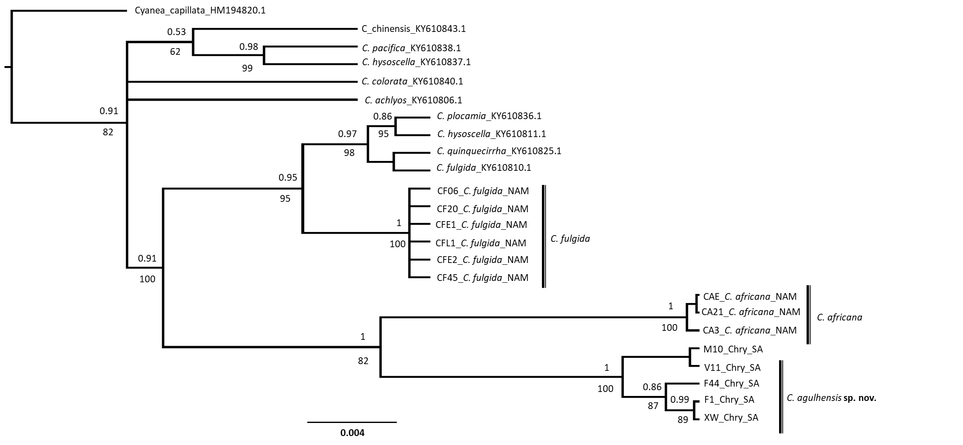

S4: Mean pairwise genetic distance matrix of the ITS1 gene region, for the monophyletic clades of Chrysaora. Evolutionary analyses were conducted in MrBayes v4.1.3. All measures represented as mean ± standard error.
ITS1
 | Cyanea capillata | C. africana | C. fulgida | C. agulhensis sp. nov. | C. pacifica | C. hysoscella
Cyanea capillata | - | -
C. africana | 0,261 ± 0,027 | 0,009 ± 0,005 | -
C. fulgida | 0,215 ± 0,026 | 0,211 ± 0,026 | 0,003 ± 0,000 | -
C. agulhensis sp. nov. | 0,212 ± 0,026 | 0,204 ± 0,022 | 0,011 ± 0,007 | 0,007 ± 0,004
C. pacifica | 0,257 ± 0,027 | 0,172 ± 0,024 | 0,216 ± 0,005 | 0,210 ± 0,024 | -
C. hysoscella | 0,230 ± 0,027 | 0,220 ± 0,025 | 0,055 ± 0,014 | 0,05 ± 0,014 | 0,226 ± 0,024 | -

S5: Mean pairwise genetic distance matrix of the ITS2 gene region, for the monophyletic clades of Chrysaora. Evolutionary analyses were conducted in MrBayes v4.1.3. All measures represented as mean ± standard error.
ITS2
 | Cyanea capillata | C. africana | C. fulgida | C. agulhensis sp. nov. | C. pacifica
Cyanea capillata | -
C. africana | 0,413 ± 0,042 | -
C. fulgida | 0,280 ± 0,038 | 0,293 ± 0,039 | -
C. agulhensis sp. nov. | 0,280 ± 0,038 | 0,300 ± 0,039 | 0,007 ±0,006 | -
C. pacifica | 0,360 ± 0,042 | 0,22 ±0,033 | 0,187 ± 0,032 | 0,193 ±0,033 | -

S6: Rooted Bayesian ITS1 tree using TIM2+I+G model of evolution, Geographic information on collecting sites is provided in Table 1. Posterior probabilities and bootstrap support values are given above and below branches respectively. Dotted lines indicate alternative topologies present in Maximum Likelihood analyses (if any were present).
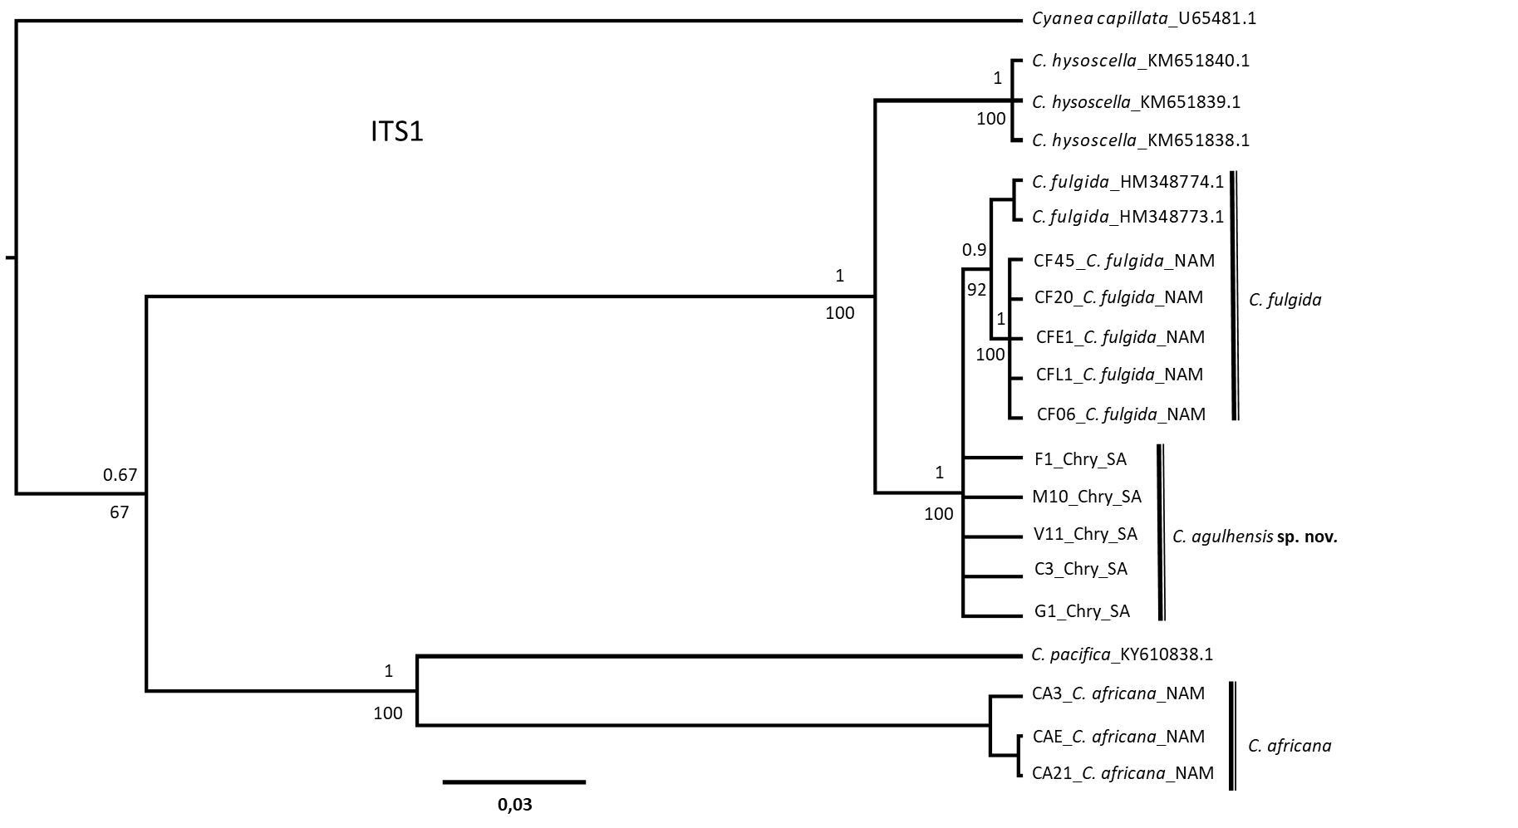

S7: Rooted Bayesian ITS2 tree using TIM2+I+G model of evolution, Geographic information on collecting sites is provided in Table 1. Posterior probabilities and bootstrap support values are given above and below branches respectively. Dotted lines indicate alternative topologies present in Maximum Likelihood analyses (if any were present).
